

**College code: 5113**

**Batch members:**

**1. JEEVANANDHAN.T (au511321104037)** [**tjeevanandhanjaya2004@gmail.com**](mailto:tjeevanandhanjaya2004@gmail.com)

**2. KABILAN.K (au511321104038)** [**kabilan0701@gmail.com**](mailto:kabilan0701@gmail.com)

**3. LOKESH KUMAR.V (au511321104049)** [**lokeshkumarlucky06@gmail.com**](mailto:lokeshkumarlucky06@gmail.com)

**4. JAYABALAJI .A (au511321104033)** [**jayabalaji445@gmail.com**](mailto:jayabalaji445@gmail.com)

**5. KARTHIKEYAN.S (au511321104041)** [**karthikeyan2003b3@gmail.com**](mailto:karthikeyan2003b3@gmail.com)

**CLOUD APPLICATION DEVELOPMENT**

**PROJECT 10: Media Streaming with IBM Cloud Video Streaming**

**Introduction**

The project at hand is to create a virtual cinema platform using IBM Cloud Video Streaming. This ambitious endeavor aims to provide a platform where users can upload and stream their favorite movies and videos on-demand, transcending geographical boundaries and offering a truly immersive cinematic experience. To embark on this journey, it's imperative to have a clear understanding of the problem statement and to create a comprehensive project document that will guide us through the development process. In this document, we will delve into how to understand the problem statement and structure the project document to proceed effectively.

**Understanding the Problem Statement**

**Problem Definition**

The first step in any project is to precisely define the problem. In this case, the problem is to establish a virtual cinema platform using IBM Cloud Video Streaming. This involves creating a platform where users can upload their video content and then stream it on-demand. The main objectives include user registration, video uploading, on-demand streaming, and ensuring a smooth, high-quality cinematic experience.

**User Registration**

User registration is an integral part of the platform. This is where users create accounts, providing their details, and gaining access to the features of the virtual cinema platform. It's essential to consider security and user privacy when designing this feature.

**Video Upload**

The video upload feature allows users to contribute content to the platform. This content can be movies, videos, or any other media files. It's crucial to ensure that the upload process is user-friendly and efficient.

**On-Demand Streaming**

The heart of this project is on-demand streaming. Users should be able to select a video and start watching it immediately, regardless of their location. Smooth playback and high-quality video streaming are non-negotiable here.

**Seamless and Immersive Experience**

The ultimate goal is to provide a seamless and immersive cinematic experience. This means that the platform's user interface should be intuitive, video streaming should be uninterrupted, and the quality of video playback should be exceptional.

**Design Thinking**

With the problem statement understood, the next step is to employ design thinking to create a structured plan for the project.

**Platform Definition**

Defining the platform involves listing all the features and functionalities it should possess. This includes user registration, video upload, and on-demand streaming. Each feature needs to be detailed and defined clearly.

**User Interface Design**

Creating an intuitive and user-friendly interface is vital. The user interface (UI) should allow users to navigate the platform effortlessly, search for content, and watch videos with ease. Consideration should be given to the layout, color schemes, and overall aesthetics.

**Video Upload**

The video upload process must be well-designed. Users should be able to upload content easily, with clear instructions on formats, sizes, and any limitations. This part of the design also needs to consider aspects of video transcoding and storage.

**Streaming Integration**

Integrating IBM Cloud Video Streaming services is a key part of the project. This involves understanding the APIs, setting up the necessary configurations, and ensuring that the platform communicates effectively with the streaming service for a seamless playback experience.

**User Experience**

The user experience (UX) is pivotal. This aspect encompasses the entire journey a user goes through, from registration to selecting and watching a video. Focusing on providing a seamless and immersive experience is at the core of the design.

**Innovation**

In Phase 2, we will explore innovative features to enhance the movie-watching experience. This could involve incorporating user-generated playlists or real-time chat, making the platform more engaging and social. Innovation will keep the platform competitive and enticing to users.

**Creating the Project Document**

Now that we have a clear understanding of the problem statement and have employed design thinking to outline the project's key elements, it's time to create a structured project document. This document will serve as a roadmap, guiding the project from conception to completion.

**Phase 1: Problem Definition and Design Thinking**

**1.1 Platform Definition**

* List and detail the features and functionalities of the virtual cinema platform.
* Define user registration, video upload, and on-demand streaming.

**1.2 User Interface Design**

* Describe the layout, color schemes, and aesthetics of the user interface.
* Explain how users will navigate and interact with the platform.

**1.3 Video Upload**

* Outline the process of uploading videos to the platform.
* Mention any technical requirements for video uploads.

**1.4 Streaming Integration**

* Detail the integration with IBM Cloud Video Streaming services.
* Specify the configurations and APIs used.

**1.5 User Experience**

* Emphasize the importance of providing a seamless and immersive experience.
* Highlight the factors that will contribute to a positive user experience.

**Phase 2: Innovation**

**2.1 Innovative Features**

* Discuss the introduction of innovative features like user-generated playlists or real-time chat.
* Explain how these features will enhance the movie-watching experience.

**Phase 3: Development Part 1**

**3.1 Platform Development**

* Begin the actual development of the virtual cinema platform.
* Set milestones and timelines for this phase.

**Phase 4: Development Part 2**

**4.1 Integration and Testing**

* Continue the development by integrating video streaming services.
* Perform thorough testing to ensure the platform's functionality.

**Phase 5: Project Documentation**

**5.1 Project Summary**

* Provide an overview of the project's objective and scope.
* Highlight the key elements of the platform, including features, design, and innovation.

**5.2 Feature Description**

* Describe the platform's features in detail, focusing on user registration, video upload, and on-demand streaming.

**5.3 User Interface and Design**

* Explain the user interface design and its intended user experience.
* Include visual representations where applicable.

**5.4 Video Upload Process**

* Detail the video upload process, including any technical considerations.
* Discuss video transcoding and storage.

**5.5 Streaming Integration and Testing**

* Discuss the integration of IBM Cloud Video Streaming services.
* Explain the testing process and results.

**5.6 User Experience and Innovation**

* Reflect on the importance of providing a seamless and immersive user experience.
* Discuss any innovative features incorporated in the project.

**Transforming Design into Innovation**

Introduction

In the previous phase, we meticulously defined the problem statement and engaged in comprehensive design thinking to shape our approach for creating a virtual cinema platform. This platform aims to allow users to upload and stream their favorite movies and videos on-demand, delivering a seamless and immersive cinematic experience. In this phase, we will embark on the journey of transforming our well-thought-out design into a true innovation that solves the problem at hand. This document outlines the complete steps we will undertake to achieve this transformation.

Recap of Design Thinking

Before we delve into the steps of innovation, let's briefly recap the design elements that we outlined in the previous phase:

Platform Definition: We defined the features and functionalities of the virtual cinema platform, including user registration, video upload, and on-demand streaming.

User Interface Design: We designed an intuitive and user-friendly interface, ensuring ease of navigation, content discovery, and seamless video playback.

Video Upload: We laid out the process for users to upload their video content, making it user-friendly, efficient, and reliable.

Streaming Integration: We discussed the integration of IBM Cloud Video Streaming services to enable smooth video playback and streaming.

User Experience: We emphasized the need for a seamless and immersive movie-watching experience, focusing on high-quality video playback.

Phase 2: Innovation

Step 1: Feature Prioritization

Our design was comprehensive, but not all elements can be tackled simultaneously. In this step, we will prioritize features to ensure a phased approach to innovation. This involves considering which features are fundamental to the platform's functionality and user experience.

Example: User registration and on-demand streaming might be top priorities, as they form the core of the platform.

Step 2: User-Generated Playlists

One of the innovative features we proposed was the introduction of user-generated playlists. This step involves:

Detailed Design: Create a design blueprint for user-generated playlists, specifying how users can create, curate, and share playlists.

Integration Planning: Consider how playlists will be integrated into the platform, including how users will access them and their impact on content discovery.

Testing Plan: Develop a testing plan to ensure the feature works seamlessly and doesn't disrupt other platform functionalities.

Example: Users can create playlists by selecting their favorite videos, arranging them in the desired order, and sharing them with friends.

Step 3: Real-Time Chat

The other innovative feature we aim to incorporate is real-time chat for an engaging movie-watching experience. This step includes:

**Chat Design:** Create a chat system design, considering the user interface, message features, and interaction mechanisms.

**Chat Integration:** Plan how the chat system will be integrated into the platform. This might involve third-party tools or custom development.

**Moderation and Privacy:** Address concerns related to chat moderation, user privacy, and security.

Example: Users can engage in chat discussions while watching a movie, enabling real-time reactions and interactions with friends.

Step 4: Technical Integration

Now, we must turn our attention to the technical aspects of innovation. This involves integrating the features into the platform architecture.

**Development Milestones:** Break down the development process into milestones for user-generated playlists and real-time chat.

**Testing and Debugging:** Implement robust testing processes for both features to identify and address any issues.

**User Feedback Loop:** Create a mechanism to gather user feedback during the development process and make necessary adjustments.

Example: User-generated playlists and real-time chat will be developed as separate components, each with its own set of milestones and testing phases.

Phase 3: Implementation

With the design transformed into innovation, it's time to implement the features. Each feature will go through its development cycle.

Step 1: User-Generated Playlists Development

**Feature Development:** The user-generated playlists feature will be developed according to the design plan.

**Testing:** Rigorous testing, including user testing for usability and bug testing, will be conducted.

**Feedback Integration:** User feedback during testing will be integrated to refine the feature.

Example: Users can now create playlists, add videos, and arrange them as they please. Feedback will be collected to improve user experience.

Step 2: Real-Time Chat Development

**Chat System Development:** The real-time chat feature will be developed, including message handling and interaction mechanisms.

**Security Measures:** Ensure that the chat system is secure and that user data is protected.

**Usability Testing:** Conduct usability testing to ensure the chat system is user-friendly and enhances the movie-watching experience.

Example: Users can chat in real time while watching a movie. Security measures are in place to protect user privacy.

Phase 4: Testing and Refinement

This phase involves extensive testing of both the user-generated playlists and real-time chat features.

**Beta Testing:** Select a group of users to participate in beta testing to identify potential issues and gather feedback.

**Iterative Development:** Based on feedback, make iterative improvements to the features.

**Usability Testing:** Ensure that both features are intuitive and add value to the platform.

Example: Beta testers will help identify any issues or areas for improvement. The development team will make necessary adjustments based on this feedback.

Phase 5: User Training and Deployment

Before deploying the features to the platform, a user training program will be devised to familiarize users with the new features.

**Training Materials:** Create user guides, tutorials, or videos to explain how to use user-generated playlists and the real-time chat.

**Deployment:** Gradually roll out the features to users, monitoring their adoption and feedback.

**User Support:** Provide user support and assistance for any questions or issues that may arise during adoption. Example: Users will have access to detailed guides explaining how to create playlists and use the chat feature. Deployment will be gradual to manage the process effectively.

**INTRODUCTION:**

**Phase 3: Development Part 1**

***In this part begin building your project.***

***Start building the virtual cinema platform using IBM Cloud Video Streaming.***

***Define the platform's features and design an intuitive user interface.***

***Set up user registration and authentication mechanisms to ensure secure access to the platform***

**STEP 1:**

*login our IBM CLOUD ACCOUNT

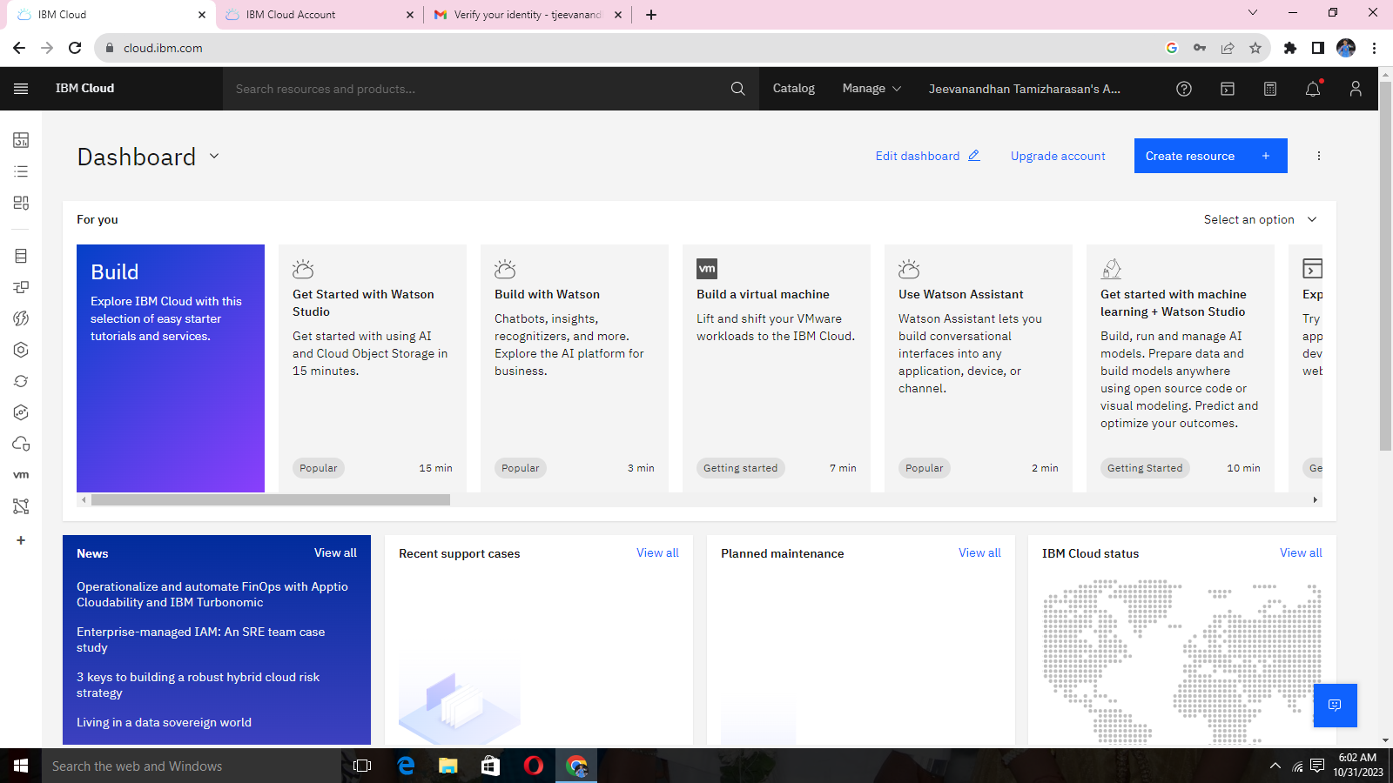

**STEP 2:**

*Open Dashboard overview

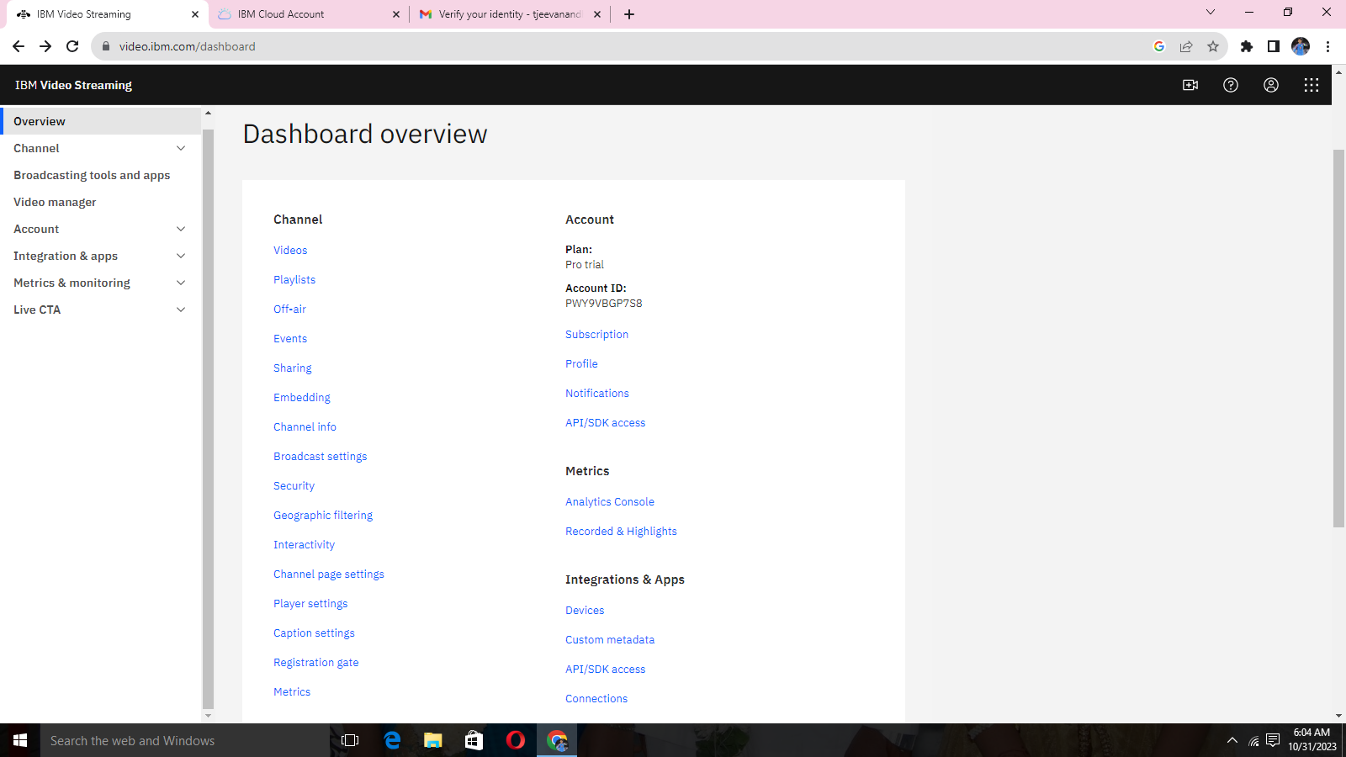

**STEP 3:**

*Upload videos

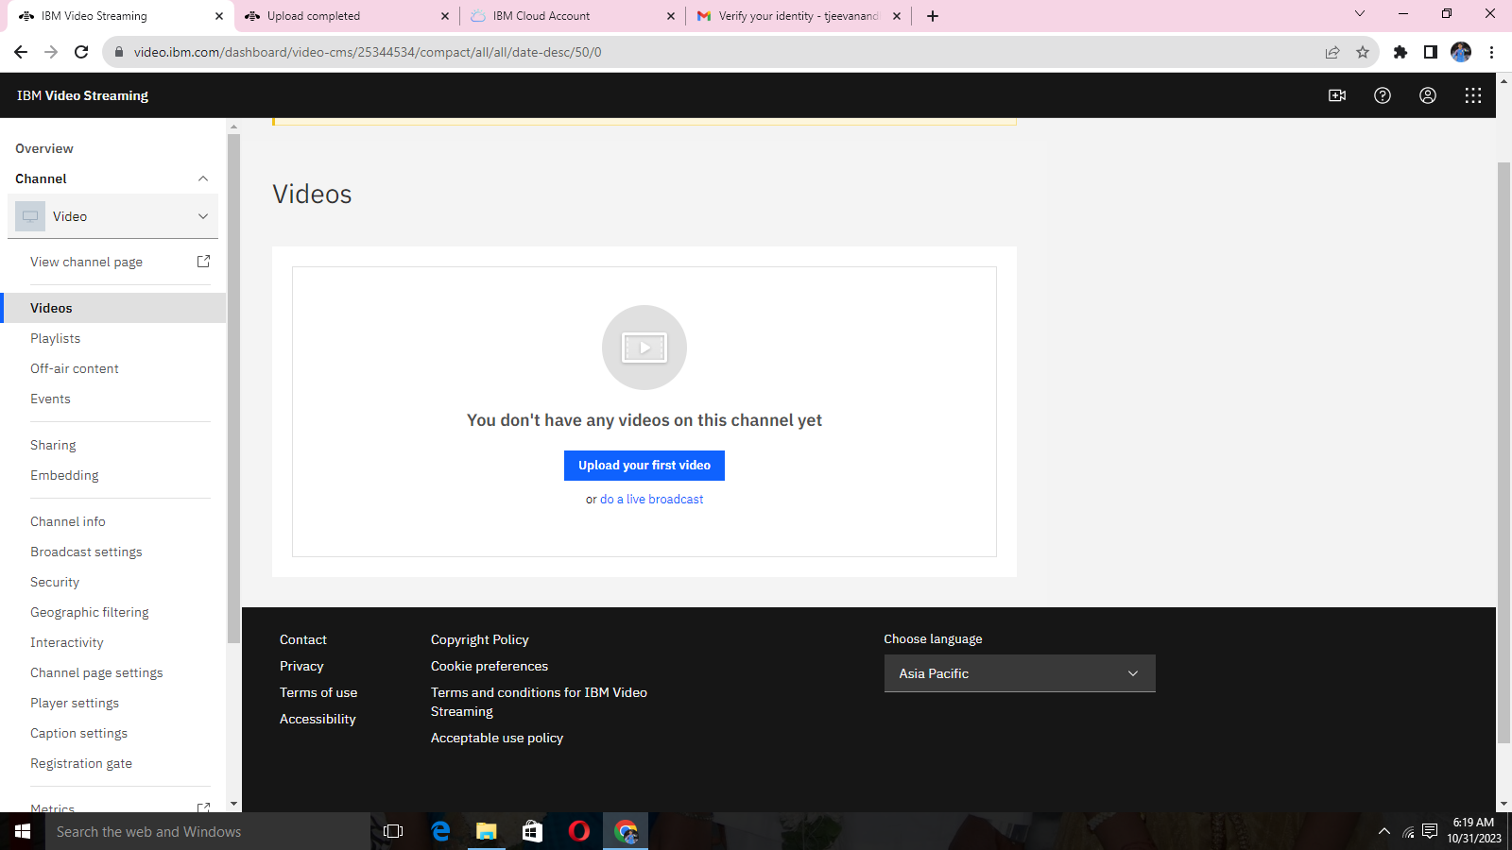

**STEP 4:**

*Video interface for uploading video

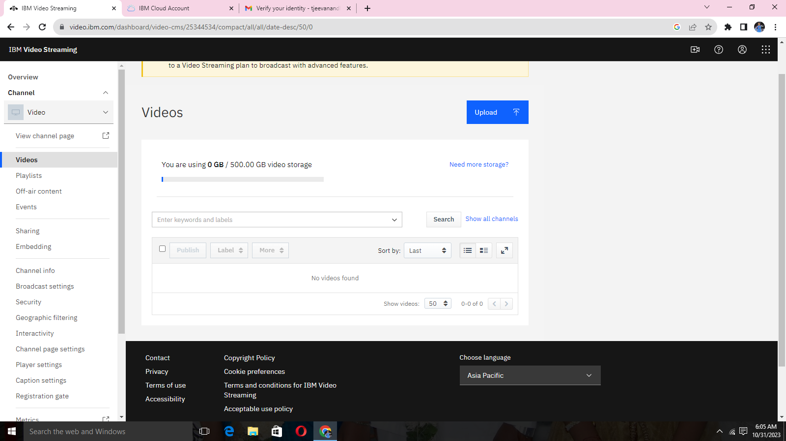

**STEP 5:**

*Select from your computer (file)

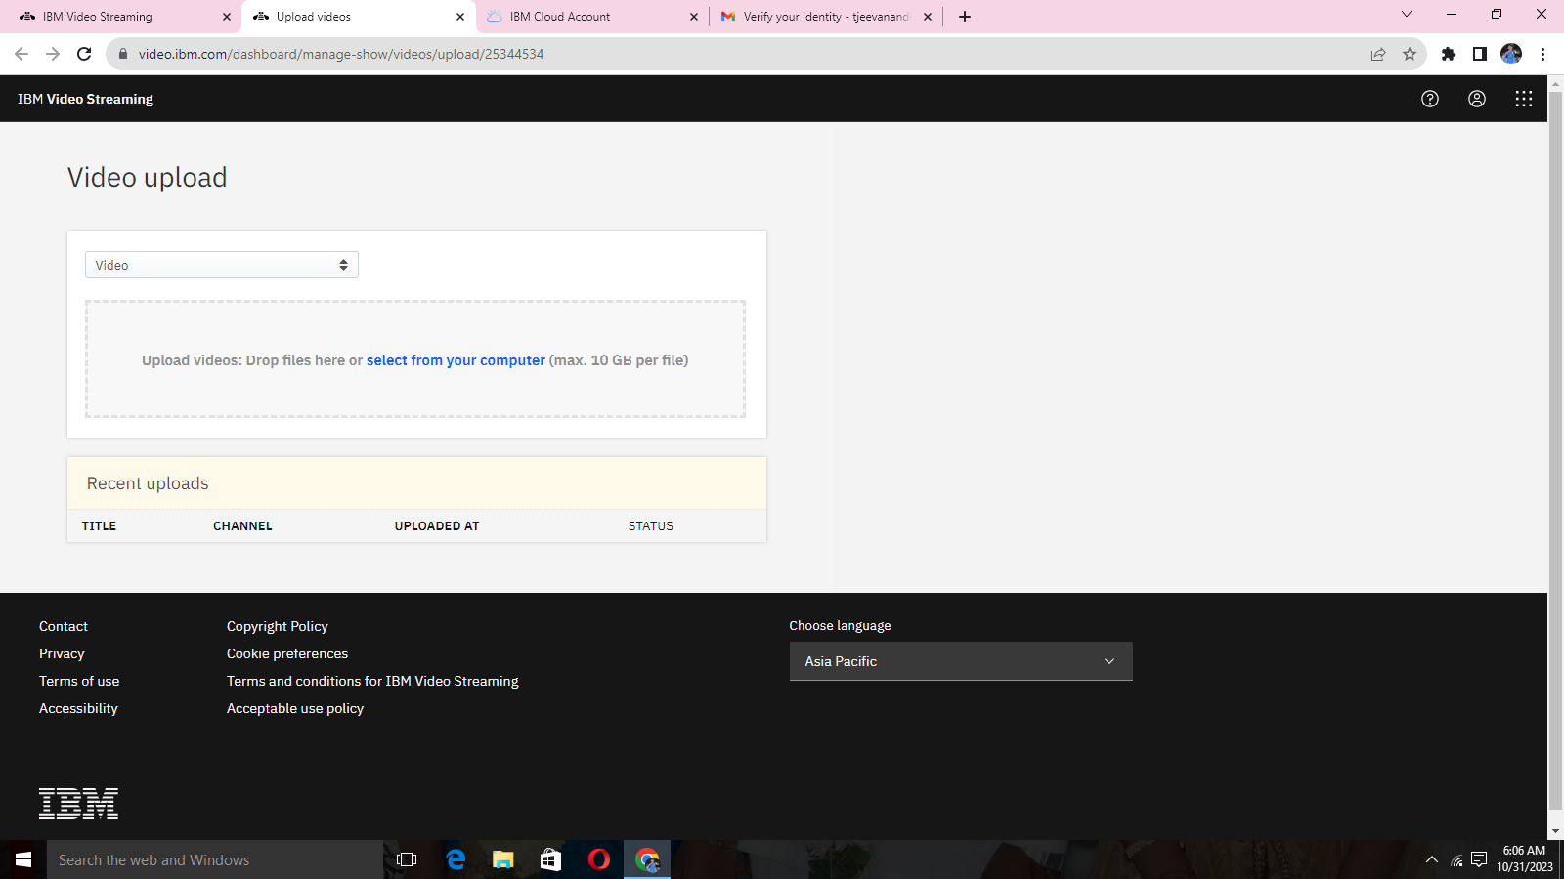

**STEP 6:**

*Select given video file

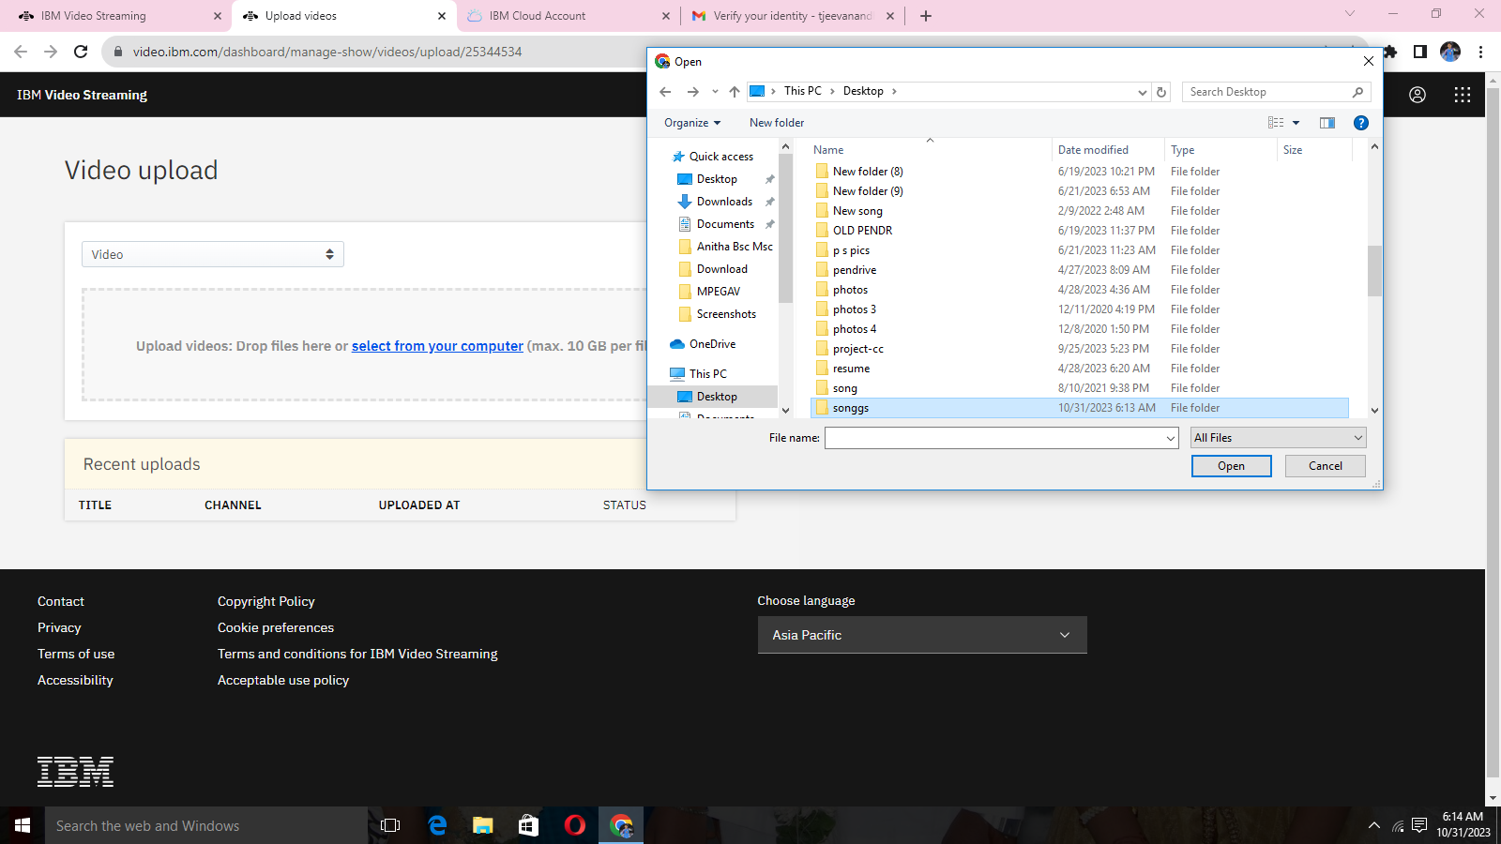

**STEP 7:**

*Add topic name and description of the video

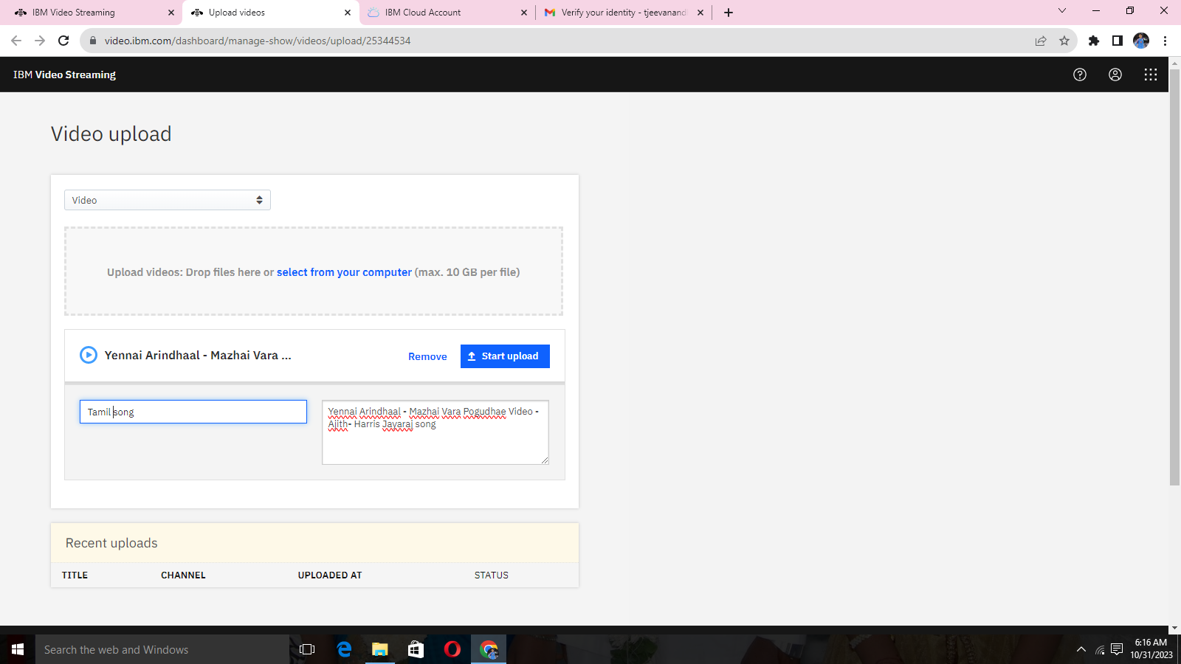

**STEP 8:**

*uploading video on process

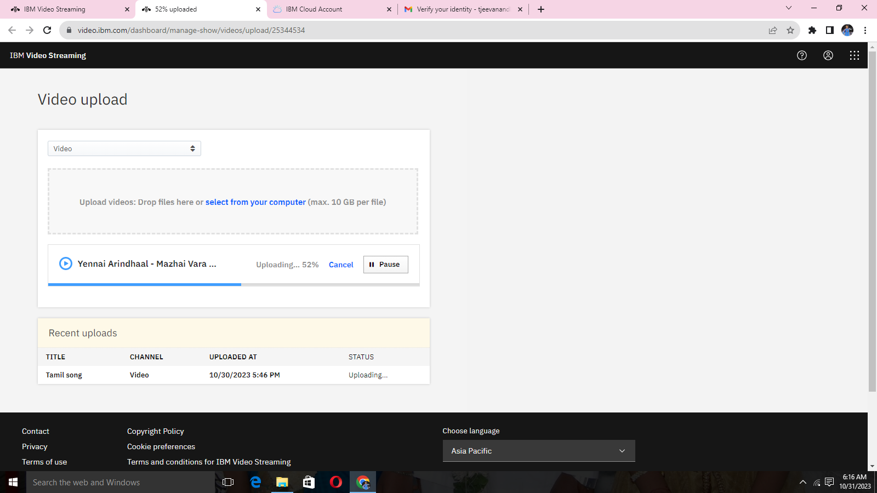

**STEP 9:**

*Publish the video to internet platform.

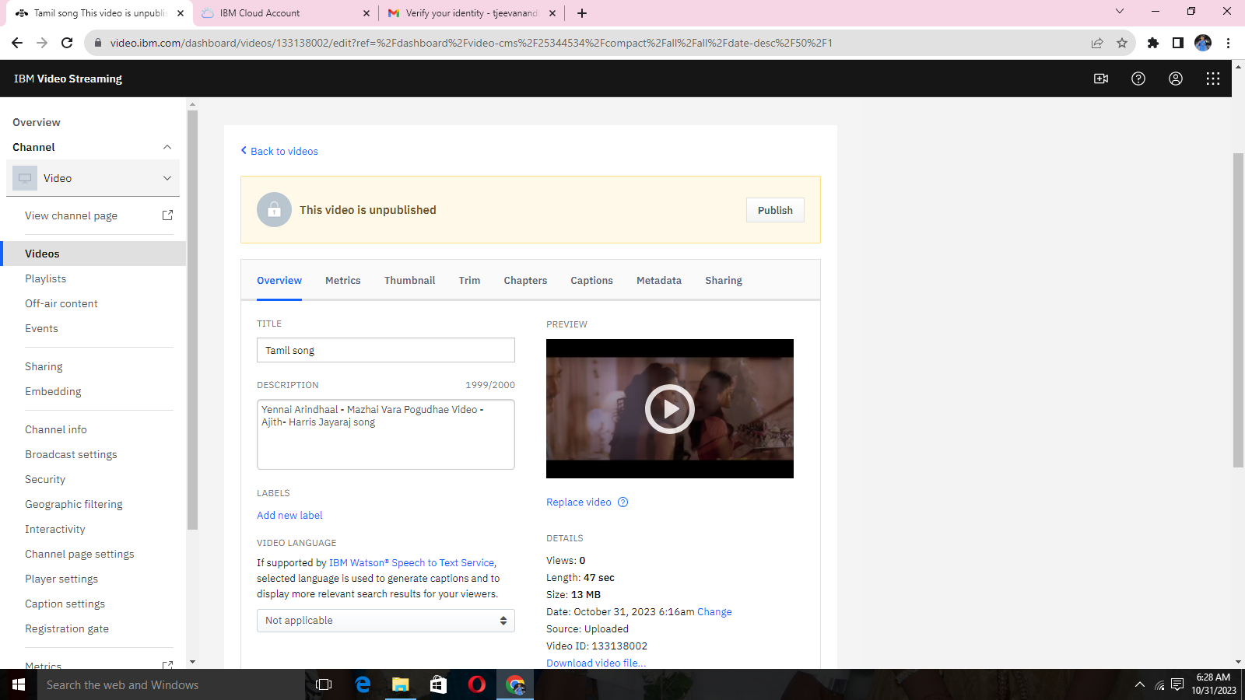

**STEP 10:**

*video information

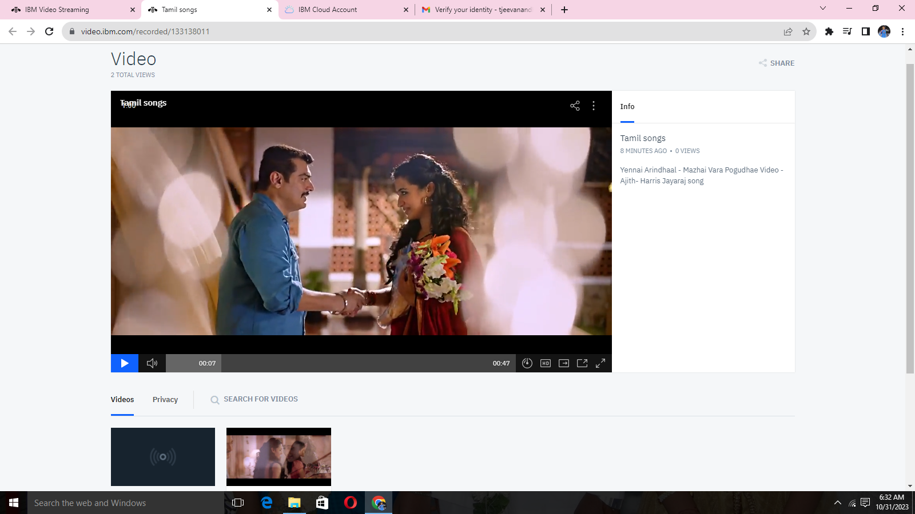

**STEP 11:**

*Metrics of uploaded video

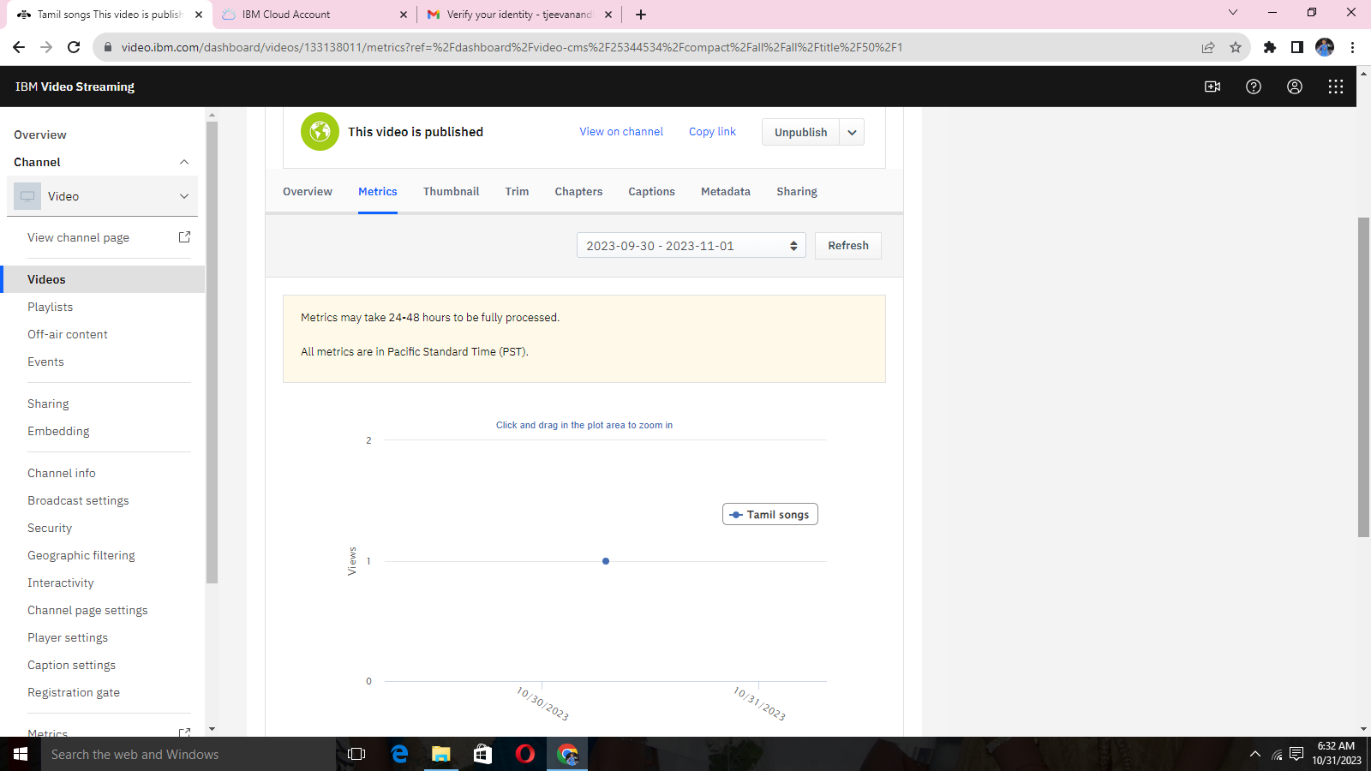

**STEP 12:**

*Thumbnail for setting the frame

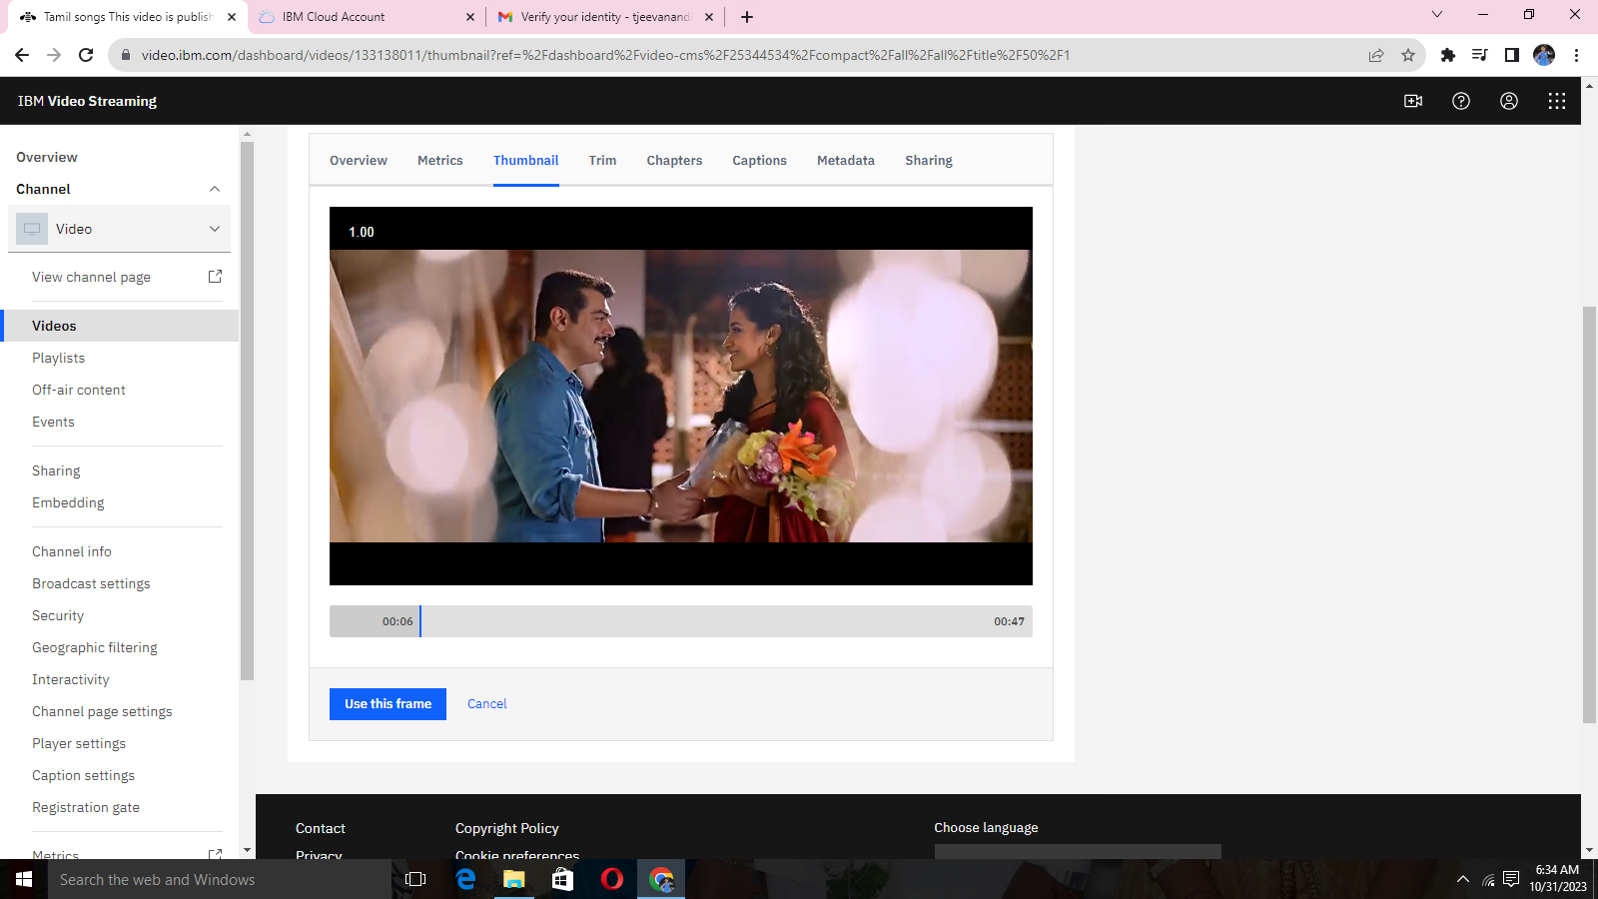

**STEP 13:**

*TRIM the uploaded video

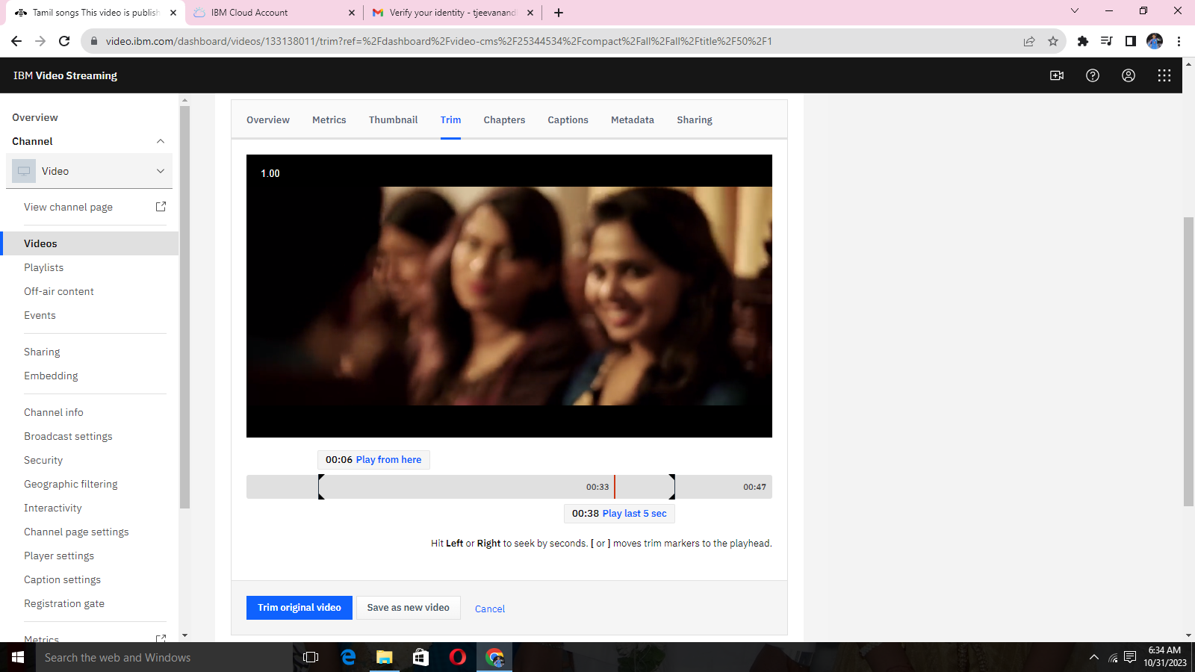

**STEP 14:**

*Add captions for the uploaded video

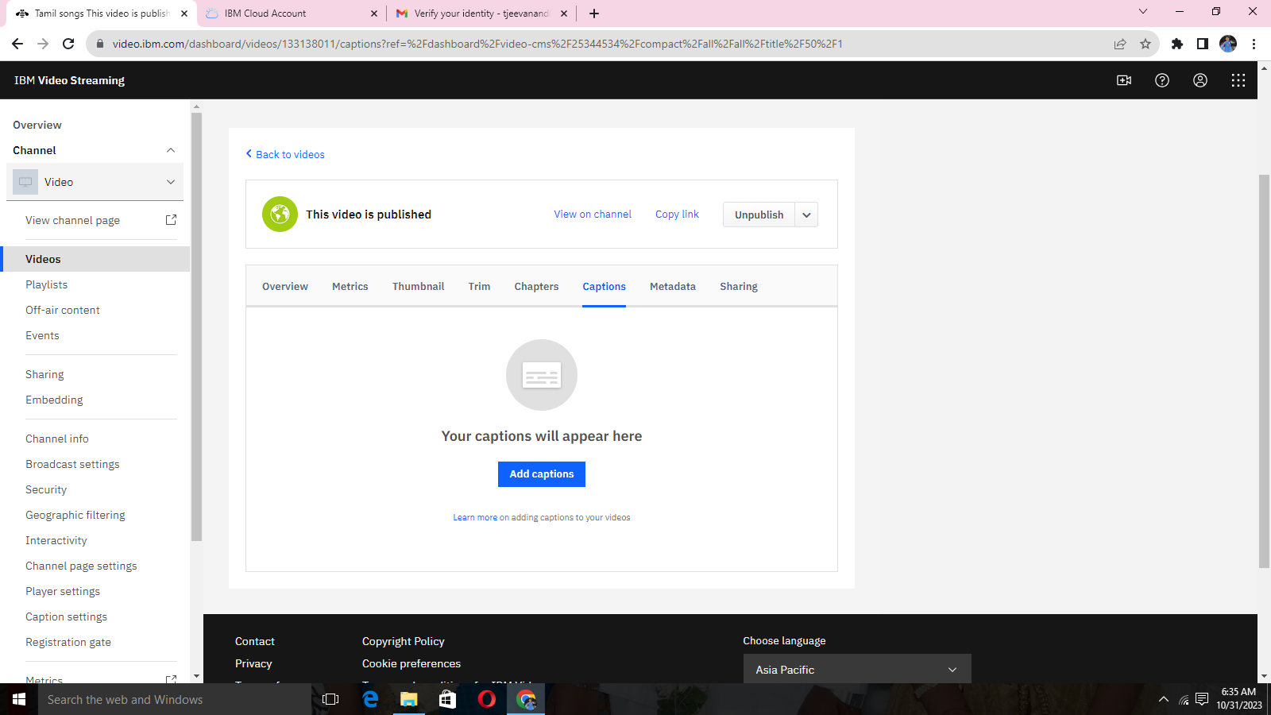

**STEP 15:**

*Security protection

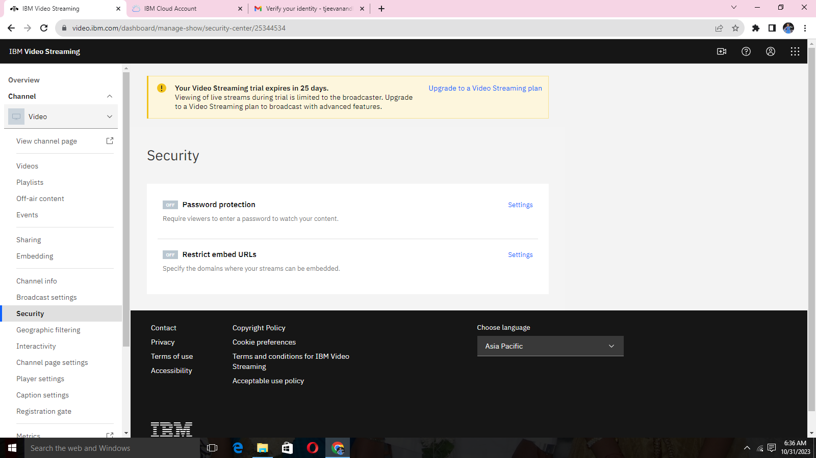

**STEP 16:**

*Set password for protection

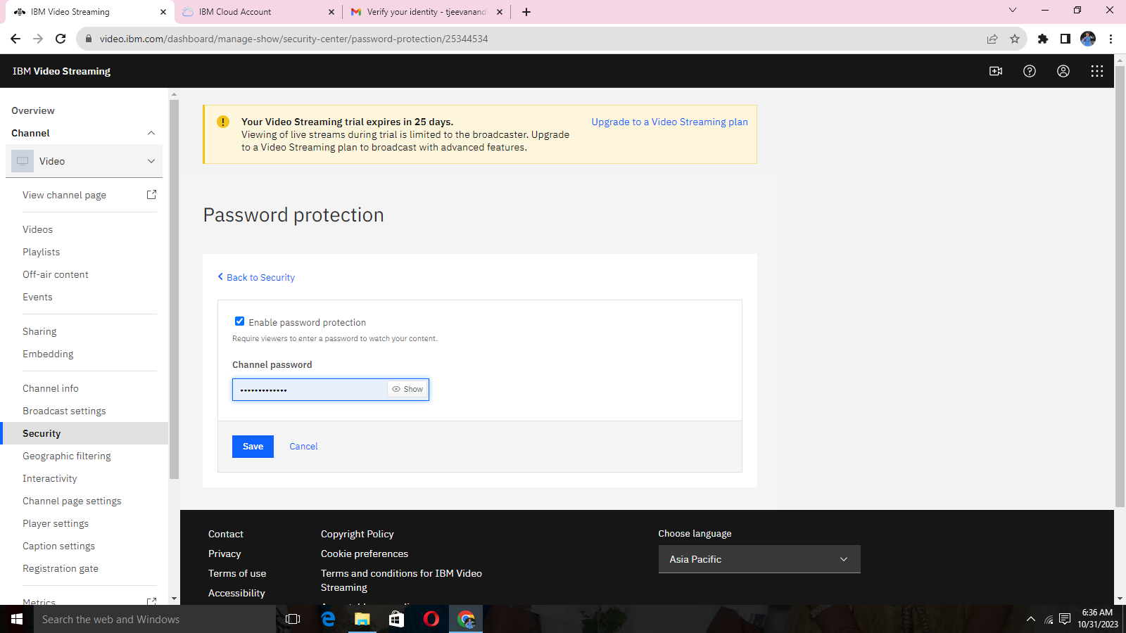

**STEP 17:**

*Embed restriction for manual URL

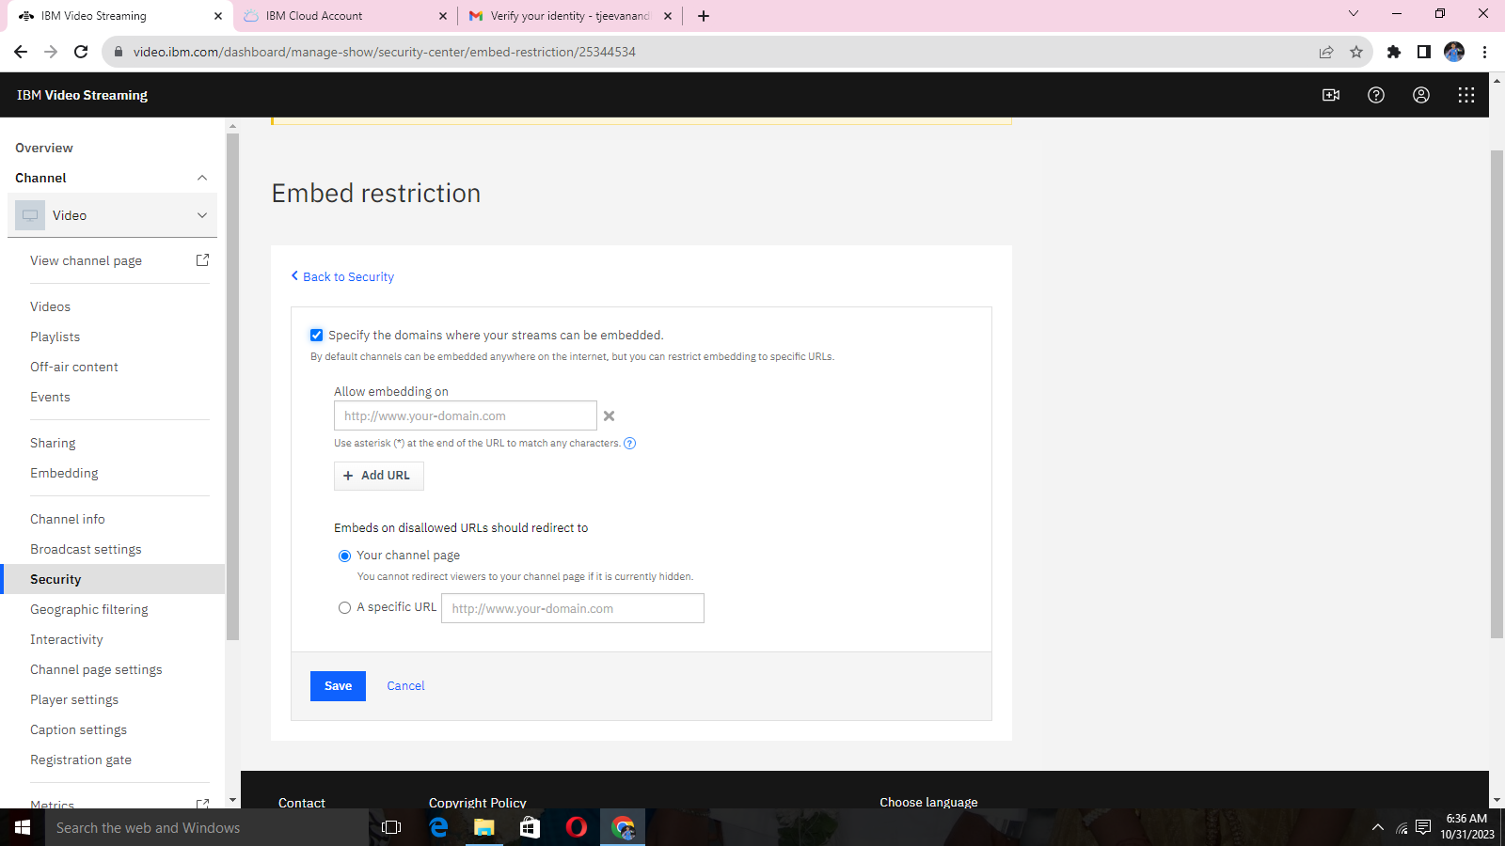

**STEP 18:**

*Interactivity for interactions with viewers

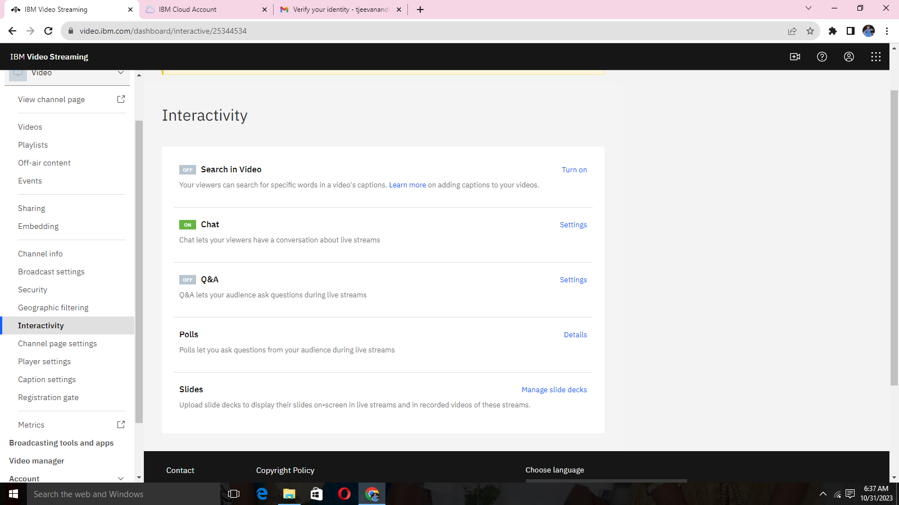

**STEP 19:**

**\***Create playlists

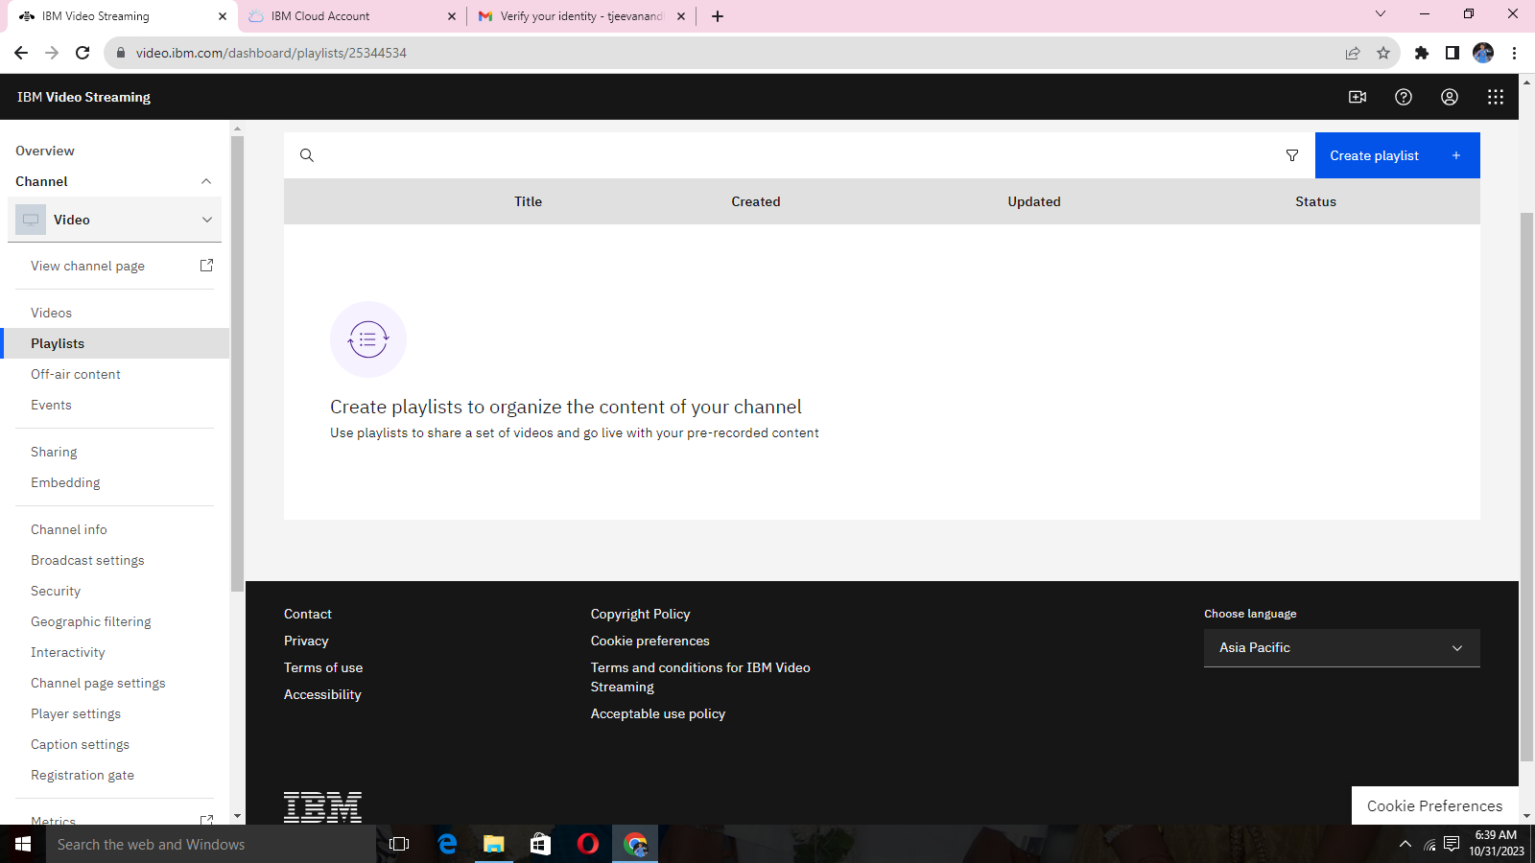

**STEP 20:**

*Playlist created

d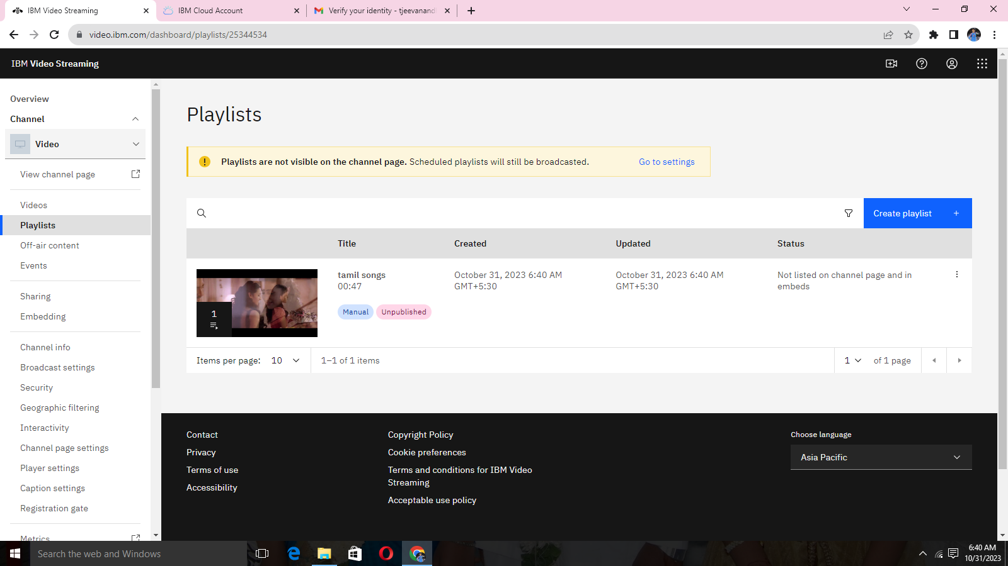

**Phase 4:**

.  Continue building the platform by integrating video streaming services and enabling on-demand playback.

By implement the functionality for users to upload their movies and videos to the platform.

Integrate IBM Cloud Video Streaming services to enable smooth and high-quality video playback.

**STEP 1:**

**\*Login our IBM CLOUD ACCOUNT**



**STEP 2:**

**\*Overview of Dashboard**



**STEP 3:**

**\*video uploading option**



**STEP 4:**

**\*Select the file or video to be uploaded.**



**STEP 5:**

**\*Upload of video on process.**



**STEP 6:**

**Video description with proper topic name.**



**STEP 7:**

**\*Video information about all the video uploaded information.**



**STEP 8:**

**\*Sharing the direct link to the channel**

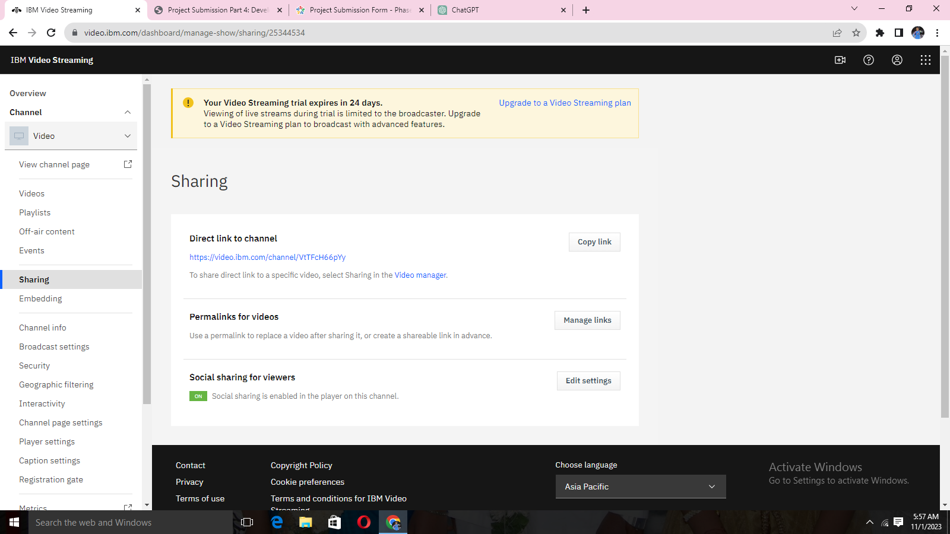

**STEP 9:**

**\*customize the sharing button in your video player.**

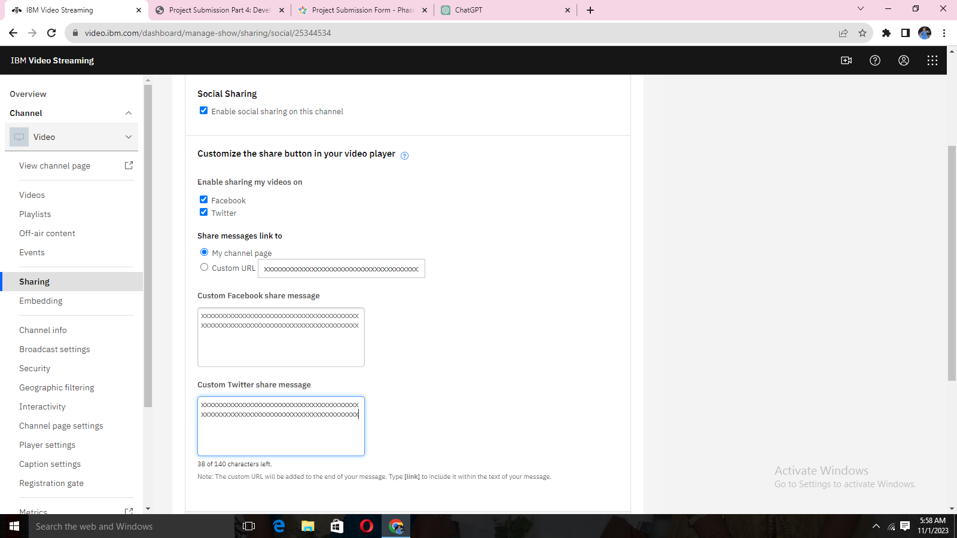

**STEP 10:**

**\*Broadcast setting in auto-recording, multi-quality streaming end encoder setting will be performed.**

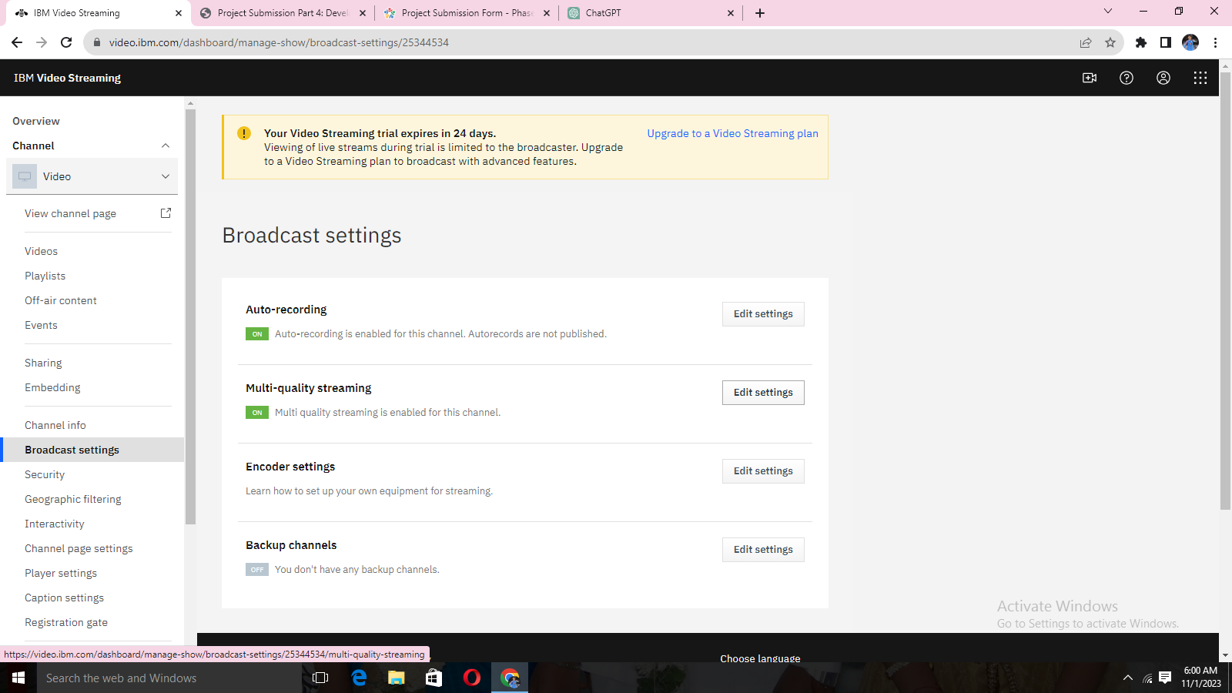

**STEP 11:**

**\*Multi-quality streaming will apply to live broadcasts. When uploaded videos will also be processed with actual setting.**

**\*for the resolutions available for viewers**

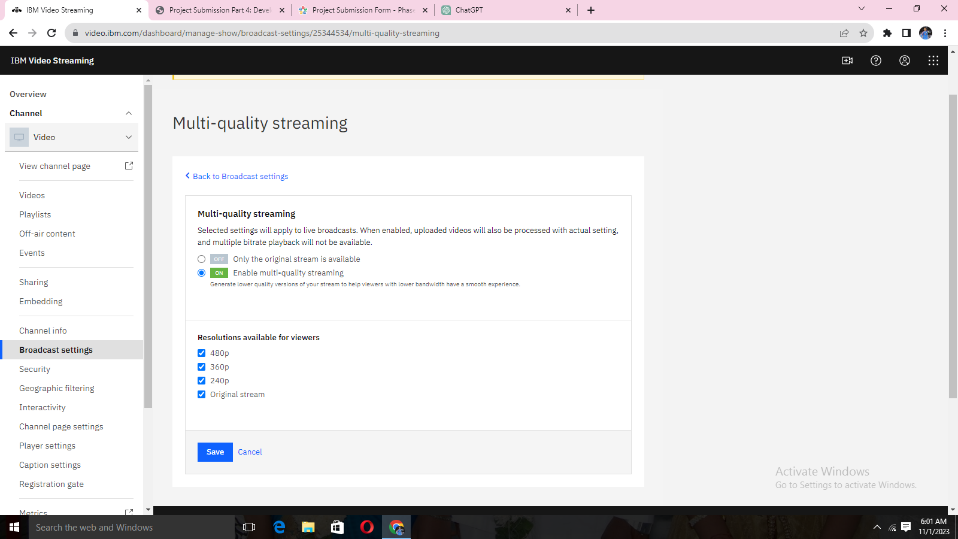

**STEEP 12:**

**\*Manual entry where values into the appropriate fields in your encoder’s configuration interface.**

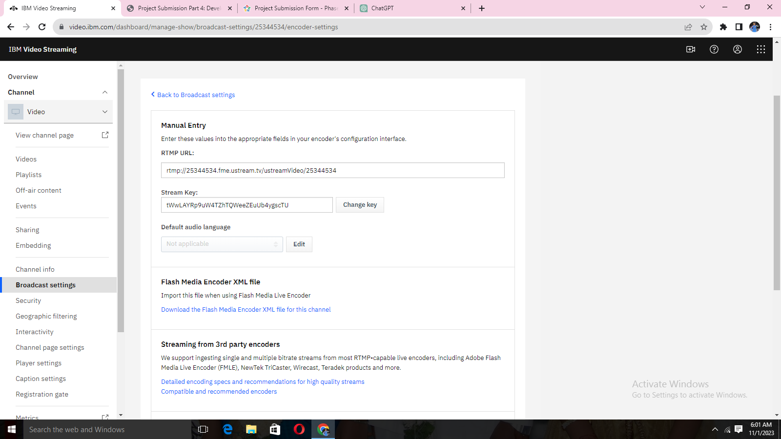

**STEP 13:**

**\*Manage interactions with your viewers during your broadcast and setup your streaming software and monitor your live broadcast.**

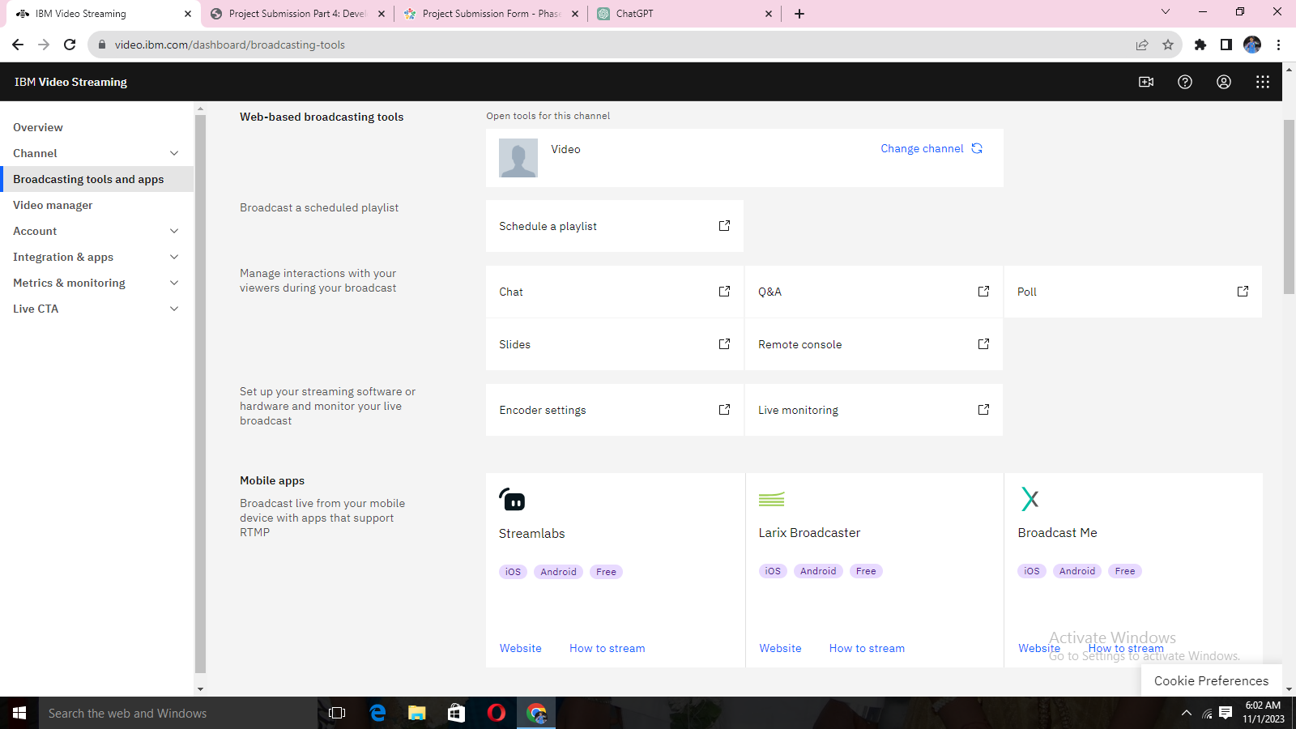

**STEP 14:**

**\*Add custom data field with type of string, numeric value, data, Boolean, tag list and link**

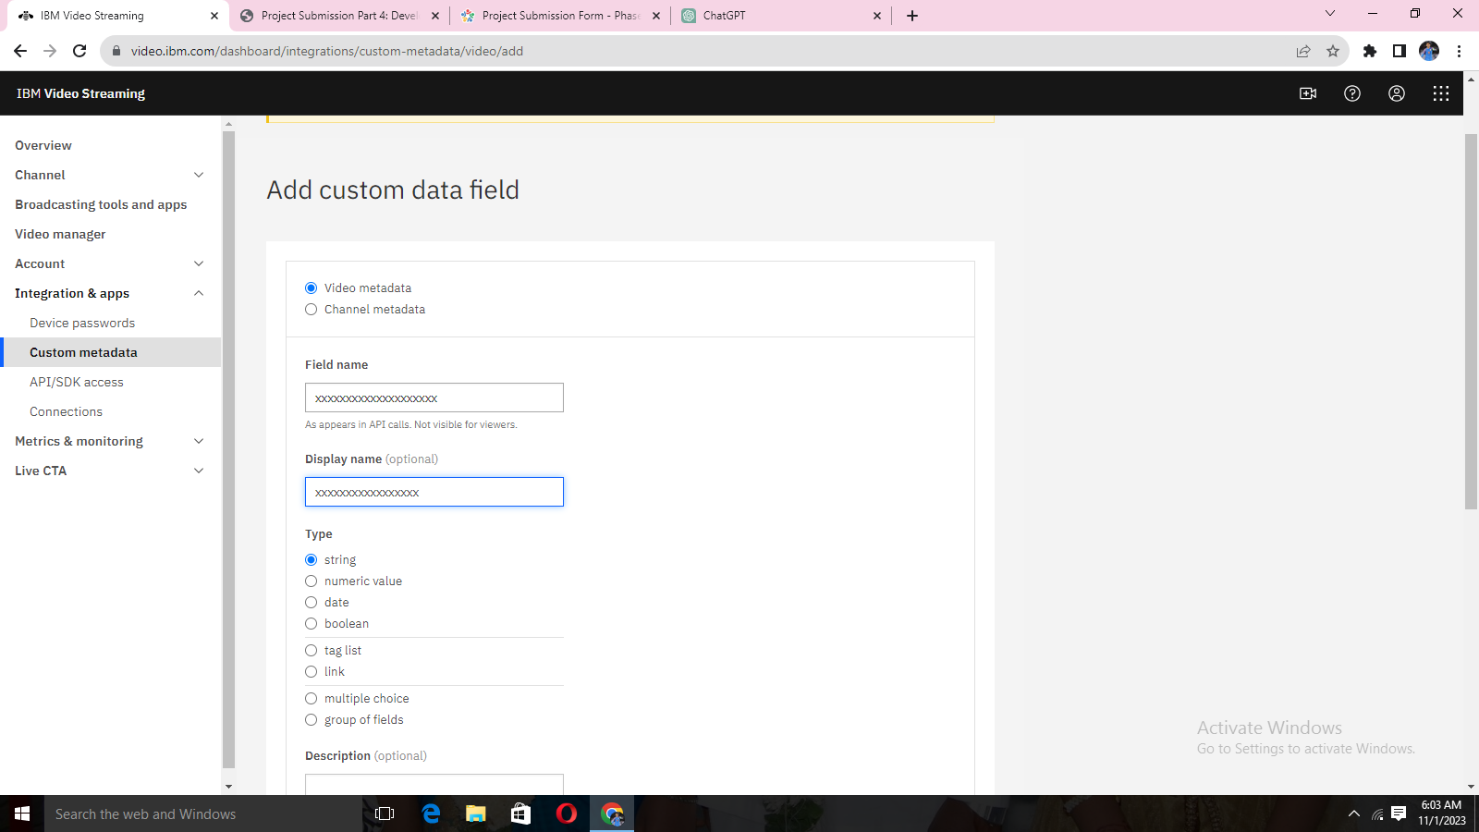

**STEP 15:**

**\*APK/SDK access to the channel in your applications need credentials, which you can create here. For detailed usage instructions, visit the documentation.**

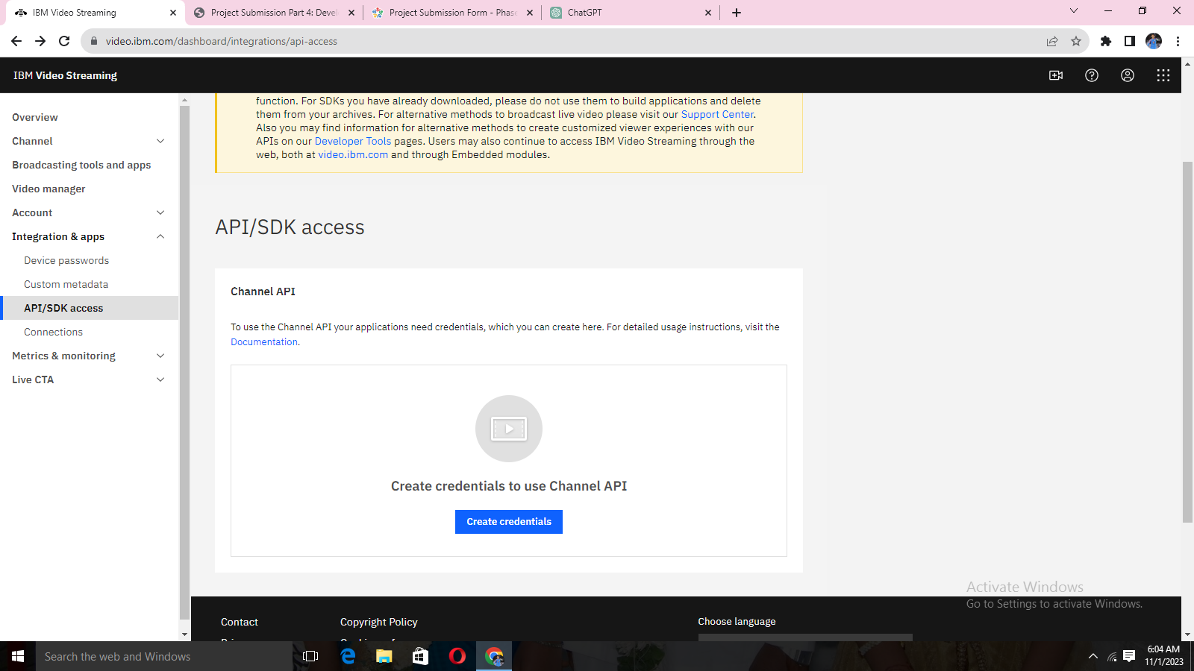

**STEP 16:**

**\*Create new credentials with application name and with redirect URL.**

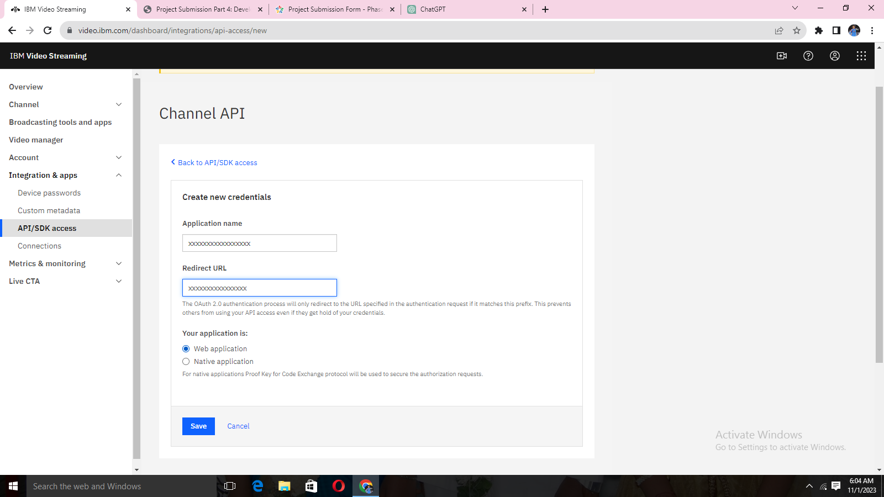

**STEP 17:**

**\*Statistics for recorded videos and highlights.**

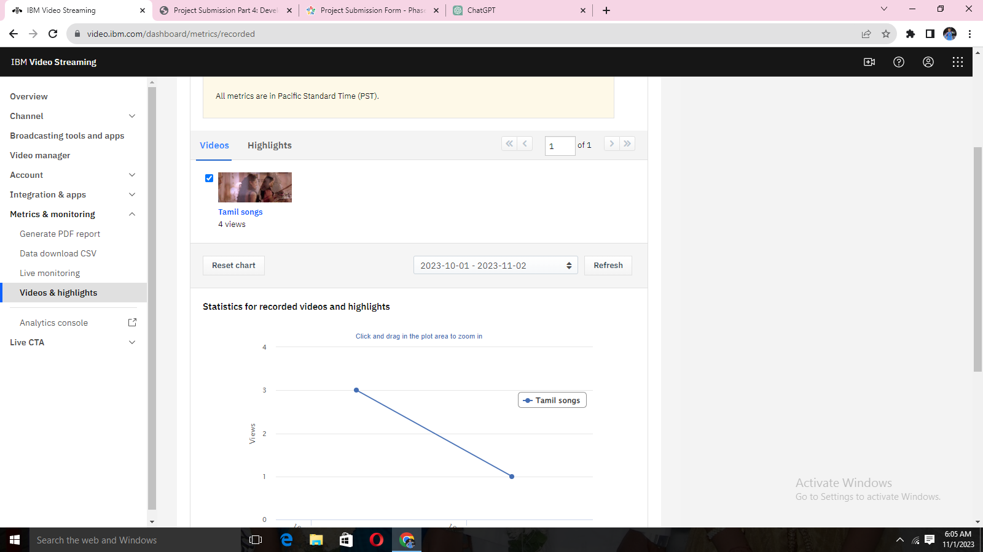

**STEP 18:**

**\*Video uploaded with high quality option. Many qualities with the speed adjust option**.

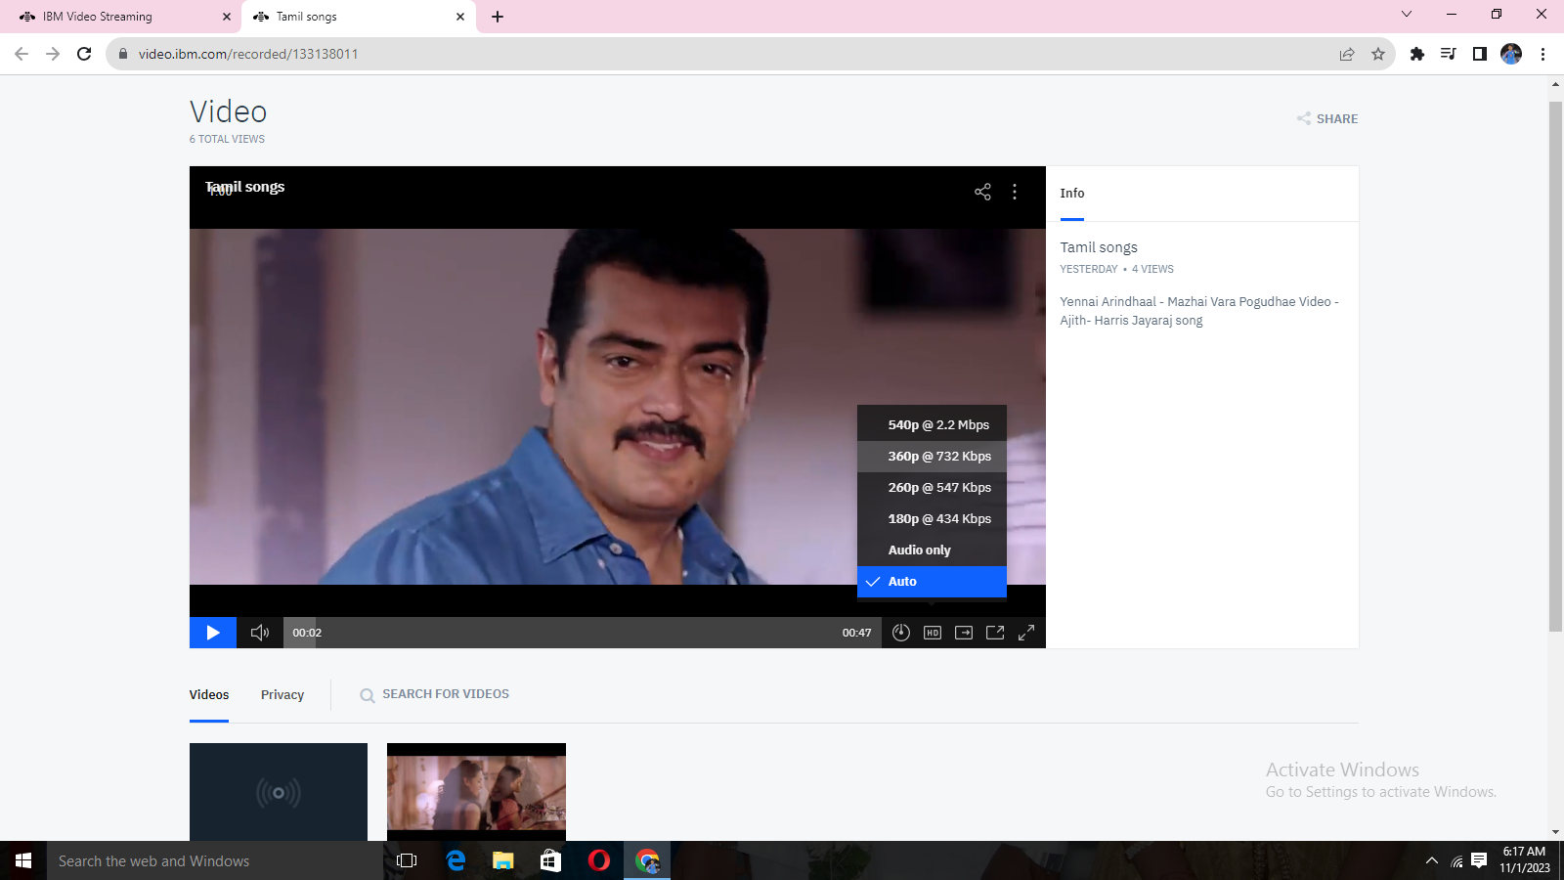

**CONCLUSION:**

In conclusion, understanding the problem statement is fundamental to project success. It ensures that the objectives are clear, and the design thinking process sets the project on the right track. Creating a project document that encompasses all these aspects provides a structured plan to follow. With this roadmap in place, the journey to creating a virtual cinema platform using IBM Cloud Video Streaming becomes more manageable and focused.

Innovation is not merely about generating creative ideas; it's about transforming those ideas into practical solutions. In this phase, we have outlined a structured approach to bringing our design to life by incorporating user-generated playlists and real-time chat into our virtual cinema platform. This transformation will not only enhance the user experience but also make our platform more engaging and competitive. By following these detailed steps, we aim to create an innovative solution that effectively addresses the problem statement, delivering a seamless and immersive cinematic experience to our users

**In this part we successfully built the project. By the virtual cinema platform using IBM Cloud Video Streaming we had uploaded the video.**

**Defined the platform's features and design an intuitive user interface.**

**User registration and authentication mechanisms has been ensured the secure access to the platform.**

Interactivity platform for interactions with viewers about the uploaded video

.  Successfully built platform by integrating video streaming services and enabling on-demand playback.

And also by implement the functionality for users to upload their movies and videos to the platform.

IBM Cloud Video Streaming services to enable smooth and high-quality video playback. 